Πολλαπλασιασμός - Διαίρεση (πίνακες 1,2,3,4,5)

6 Χ 2 =  9 Χ 2 =  1 Χ 2 =  5 Χ 2 =  7 Χ 2 =  0 Χ 2 =  3 Χ 2 =  8 Χ 2 =  4 Χ 2 =  2 Χ 2 =  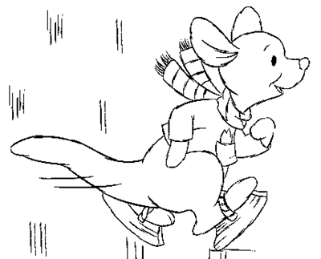  10 Χ 2 =  20 : 2 =  14 : 2 =  12 : 2 =  10 : 2 =  16: 2 =  4 : 2 =  2 : 2 =  0 : 2 =  6 : 2 =  18 : 2 =  8 : 2 =  Καλή επιτυχία παιδιά!!! | 2 Χ 3 =  6 Χ 3 =  7 Χ 3 =  9 Χ 3 =  1 Χ 3 =  4 Χ 3 =  3 Χ 3 =  5 Χ 3 =  8 Χ 3 =  10 Χ3 =  0 Χ 3 =  Και τώρα ώρα για διαίρεση!!!  18 : 3 =  15 : 3 =  3 : 3 =  9 : 3 =  12: 3 =  21 : 3 =  27 : 3 =  0 : 3 =  24 : 3 =  30 :3 =  6 : 3 = | 10 Χ 4 =  5 Χ 4 =  7 Χ 4 =  0 Χ 4 =  3 Χ 4 =  8 Χ 4 =  2 Χ 4 =  9 Χ 4 =  6 Χ 4 =  4 Χ 4 =  1 Χ 4 =  20 : 4 =  12 : 4 =  4 : 4 =  24 : 4 =  16: 4 =  0 : 4 =  8 : 4 =  28 : 4 =  40 : 4 =  36 :4 =  32 : 4 =   | 3 Χ 5 =  10 Χ 5 =  7 Χ 5 =  9 Χ 5 =  4 Χ 5 =  8 Χ 5 =  0 Χ 5 =  6 Χ 5 =  2 Χ 5 =  1 Χ 5 =  5 Χ 5 =  25 : 5 =  0 : 5 =  10 : 5 =  35 : 5 =  20: 5 =  5 : 5 =  15 : 5 =  30 : 5 =  45 : 5 =  40 :5 =  50 : 5 =

Όνομα: ___________________________Τάξη: _______

