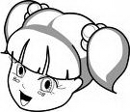

Hi! My name is……………………
I am………… years old.
I come from ……………….. (country) and live in ………………. (city or town)
Stick your photo here!
I like ……………………and …………………………….!
I am really good at……………………….
Personal informationNameFavourite sportAgeFree time activities (hobby)Date of birthFavourite musicNationalityThings you like doing
CountryThings you dislike doing
City/townFavourite foodFamily members
Favourite school subjectsAddress and phone numberThings you are good at
E-mailThings you are not good at
Occupation
Complete your personal fact file with some information about yourself:
My Personal Fact File
Go to page 2 , describe your appearance and choose some useful phrases and adjectives to introduce and describe yourself!
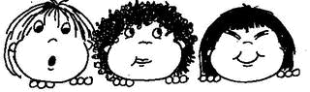
A guide for talking about and describing yourself.

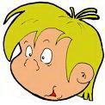
I am …………………… and ………………… I’ve got ……………eyes and ……………… ……………….. hair. My face is ……………………… and I’ve got a ……………………… nose. My skin is ………………… and I’ve got……………………… . I take after my…………………..
My appearance
Tick the information you need to describe your appearance; then fill in the gaps in the text on the right:
Now write about yourself!
Hello!!! My name is Bart Simpson and I live in Springfield, a small town in the USA. I live with my family: my father Homer, my mother Marge, my two sisters Lisa and Maggie and my two pets, my dog Santa’s Little Helper and my cat Snowball. I am 11 years old and I attend Springfield Elementary School. I am grade 4 student. I am the troublemaker of the Simpson family. I don’t like school and I am a bad student! I enjoy being naughty, causing problems, making prank phone calls and watching TV. I am crazy about skateboarding. I am lazy and cheerful. I can’t stand boring lessons and I hate Sideshow Bob and Dr Dementia. I am good at troublemaking!

Which adjectives from the list below can you use to describe your character? Circle them:
shy cheerful hardworking lazy clever optimistic pessimistic calm polite naughty rude modest funny boring awful talkative moody etc. (you can add your own adjectives to this list)
_________________________________________________________________________________________________________________________________________________________________________________________________________________________________________________________________________________________________________________________________________________________________________________________________________________________________________________________________________________________________________________________________________________________________________________________________________________________________
Now read this Bart Simpson’s personal description and write a complete story about yourself!
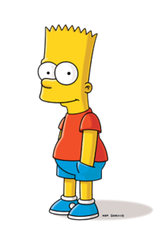
Height | tall short of medium height
Build | fat thin plump slim athletic
Eye colour | blue brown grey green
Hair colour | fair brown red blond black
Hair style | straight curly wavy afro
Face shape | round square oval triangular heart-shaped
Skin colour | fair dark tanned
Nose shape | straight turned up hooked long
Facial features | freckles dimples birthmark
Who do you take after? | mother father grand mother etc.

